1. 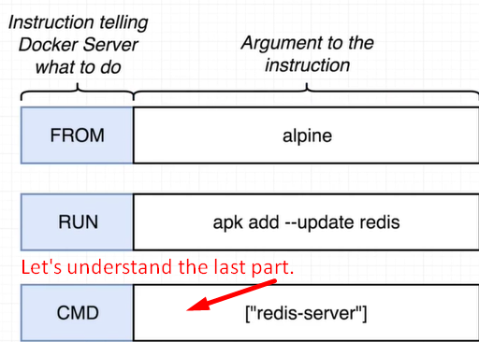
2. 
3. Let’s try to understand the structure along with the effect on each image being created during the build process.
4. Skipped